**Session-4 Assignment**

**Name: Aryan Dilipbhai Langhanoja**

**Enroll No: 92200133030**

**AIM**: To design the Half wave rectifier, Center tap Rectifier and Bridge rectifier using PN junction diode.

.

**Objective:**

1. To learn basic blocks of Power supply.
2. To learn about importance of RC filters in Power supply design.
3. To analyze output of various rectifiers in terms of ripple voltage and other parameters.

**Outcome:** Students will be able to,

1. Measure the AC RMS and Peak values and learn the practical importance of it.
2. Understand the role of transformer.
3. Measure the DC value of the rectified signal with and without capacitor filter.
4. Compare theoretical values of various voltages and current with measured practical values.
5. Identify the difference among various categories of rectifiers.

**Components and Apparatus:**

1. Diodes 1N4007
2. Different values of resistors
3. Different values of capacitors
4. AC power Supply
5. Step down transformer
6. Multimeter
7. CRO

**Task-1 Half wave rectifier without filter: (simulate in Multisim)**

**Circuit diagram: Use Step down transformer to supply AC voltage to the rectifier.**



**Simulation circuit in Multisim:**

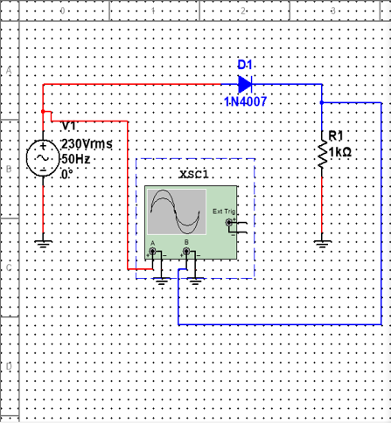

**Input and output waveforms:**

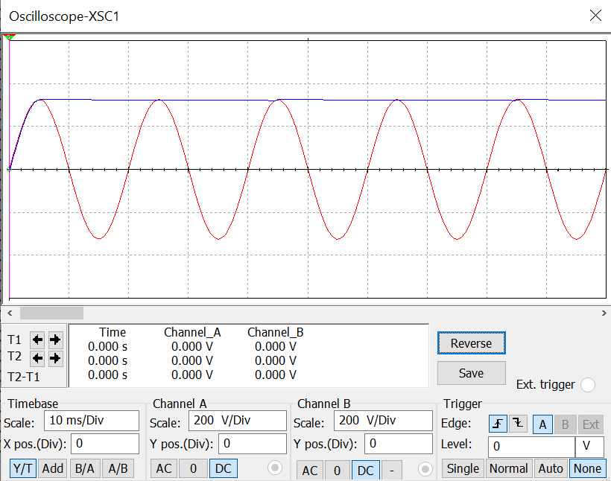

**Task-2 Half wave rectifier with filter: (simulate in Multisim)**

**Circuit diagram:**



**Simulation circuit in Multisim:**

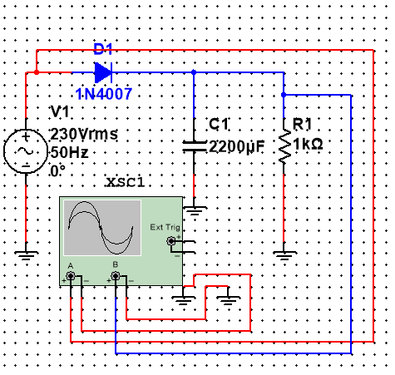

**Input and output waveforms:**



**Task-3 Centre tap rectifier without filter: (simulate in Multisim)**

**Circuit diagram:**



**Simulation circuit in Multisim:**

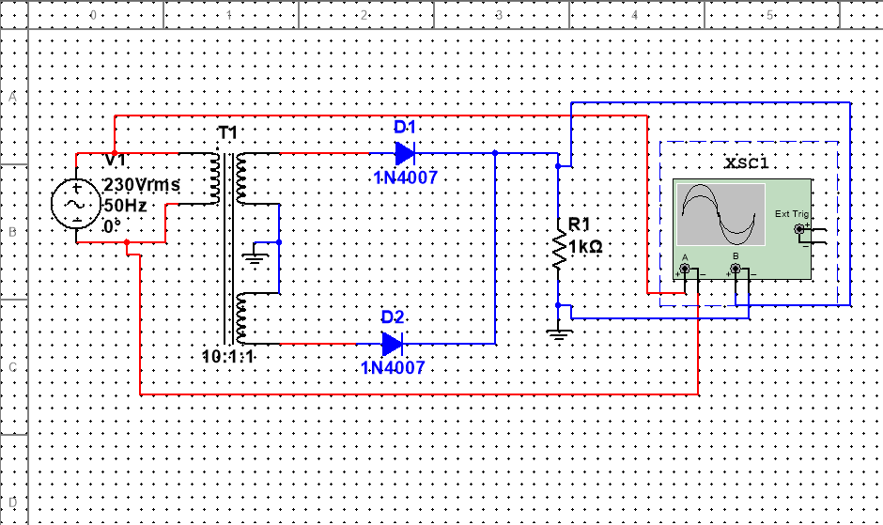

**Input and output waveforms:**

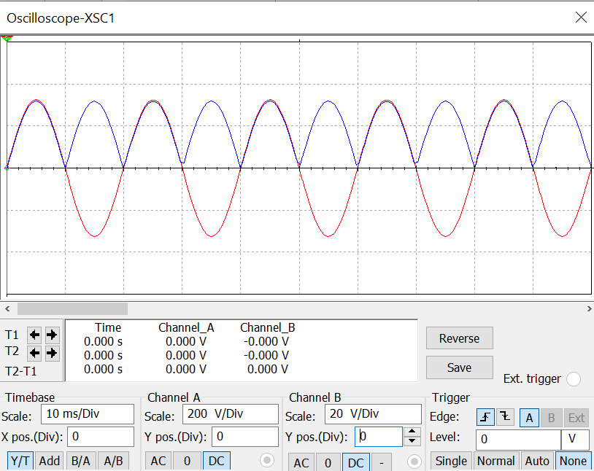

**Task-4 Centre tap rectifier with filter: (simulate in Multisim)**

**Circuit diagram:**

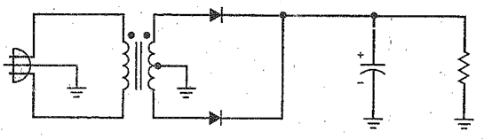

**Simulation circuit in Multisim:**

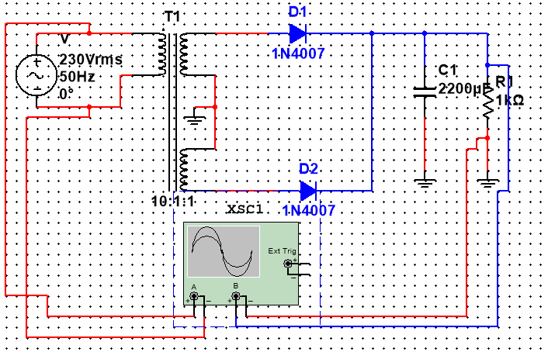

**Input and output waveforms:**

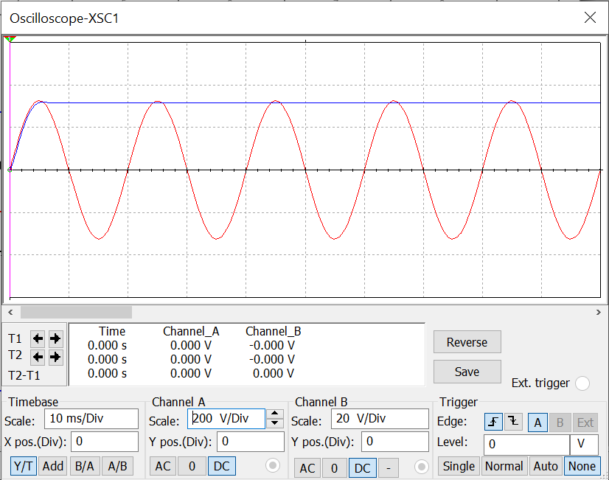

**Task-5 Full wave rectifier without filter: (simulate in Multisim)**

**Circuit diagram:**



**Simulation circuit in Multisim:**

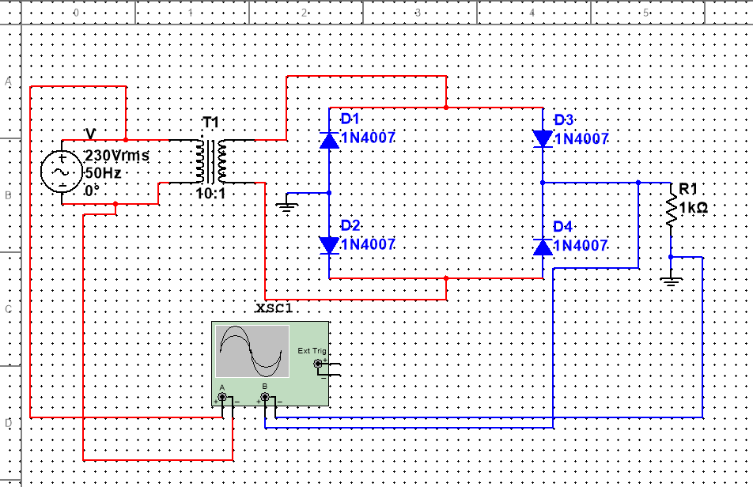

**Input and output waveforms:**

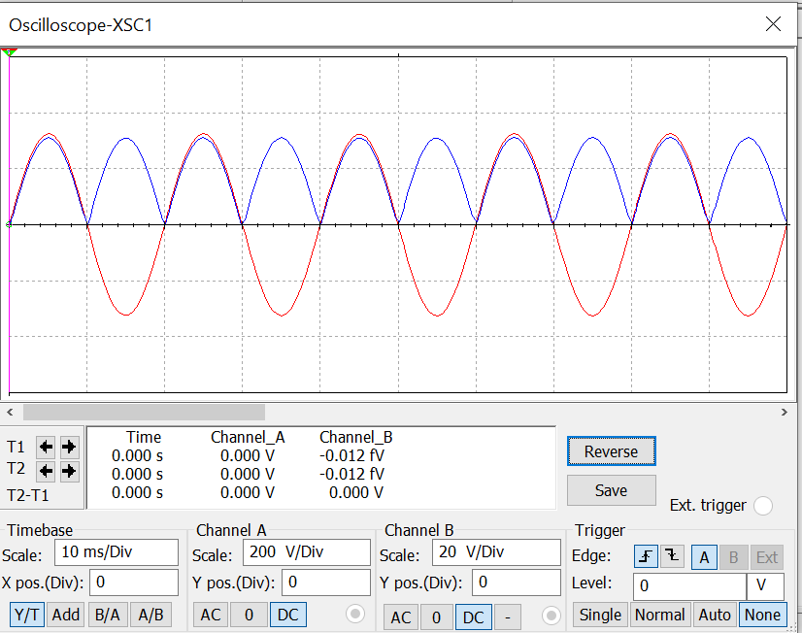

**Task-6 Full wave rectifier with filter: (simulate in Multisim)**

**Circuit diagram:**

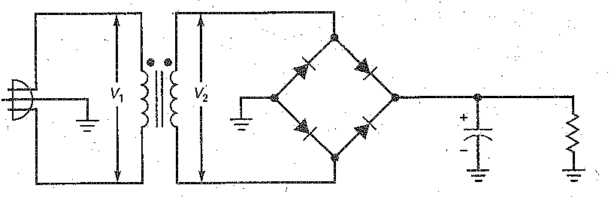

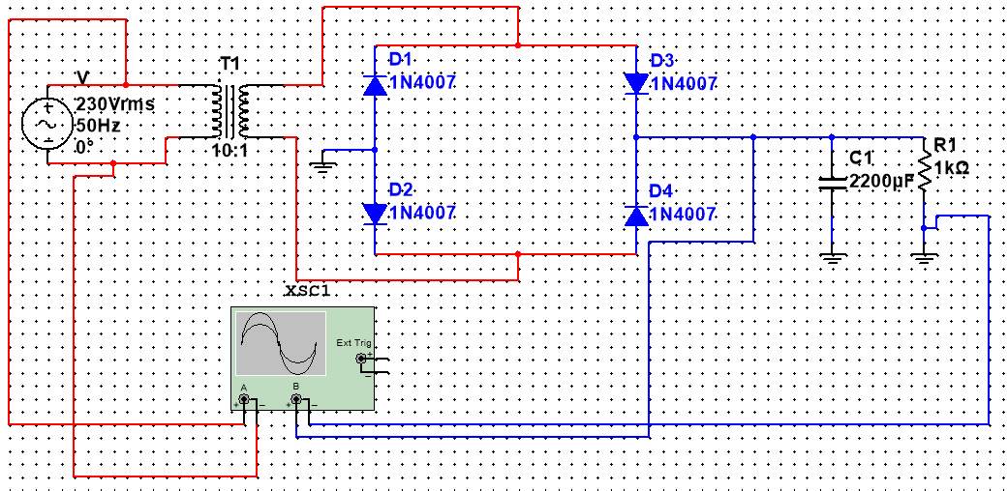**Simulation circuit in Multisim:**

**Input and output waveforms:**

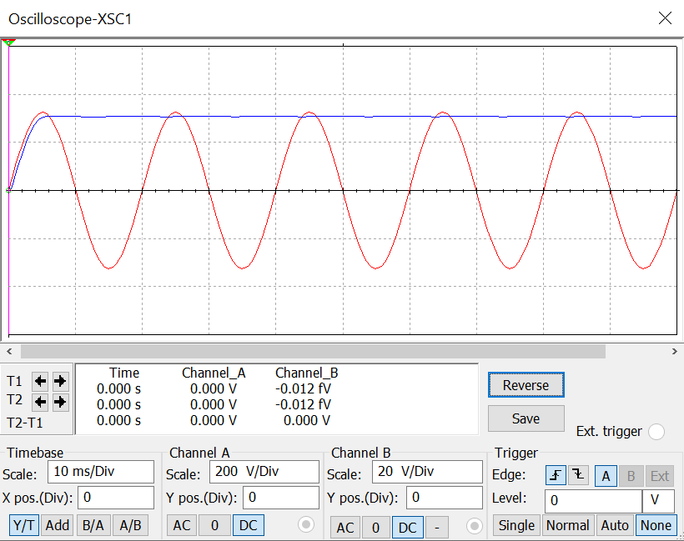

**Conclusion:**

**____________________________________________________________________________________________________________________________________________________________**